Project Report: NutriWell AI Coach Chatbot
Student Name: Saurav rajendra kamble
Candidate Registration Number: 1000323
Course: Artificial Intelligence: Real-World Applications and Implications
School:Ryan global school
Date Submitted: November 7, 2025

Executive Summary
Building the NutriWell AI Coach was one of those projects that sounded straightforward on paper but turned into a real journey of discovery. What started as a simple idea—to create a virtual nutrition coach—quickly became a lesson in how tricky human conversation can be to map into code.
I spent about three weeks building this chatbot on Google Dialogflow ES, creating 25 intents and 15 custom entities (way more than the minimum required, because real users ask things in ways you never expect). The bot helps users set fitness goals, generate meal plans based on dietary restrictions, budget, and time constraints, and sends hydration reminders.
The biggest challenge? Getting the conversation flow to feel natural. I lost count of how many times I had to rewrite parameter prompts because the bot would ask "What is the fitness_goals?" instead of sounding human. But after countless iterations and testing sessions with friends and family, I finally got it to a place where interacting with it feels like talking to a helpful friend.
Live Chatbot Link: [https://www.gstatic.com/dialogflow-console/fast/messenger/bootstrap.js?v=1"></script>
<df-messenger
intent="WELCOME"
chat-title="NutriWell-Virtual-Coach
]
GitHub Repository: https://github.com/monkey8D8luffy/NutriWellCoach

1. Problem Understanding & User Research

The Real Problem
When I first started, I thought the problem was simple: people need help with nutrition. But after talking to five classmates and my mom (who's always trying new diets), I realized the real pain points are:
- Decision fatigue: "I have 20 minutes and I'm vegetarian—what can I make that isn't boring?"
- Accountability: "I know I should drink water, but I forget until I'm thirsty."
- Personalization: "Every app gives me the same meal plan, but I'm lactose intolerant and on a tight budget."

User Personas
I created three personas based on interviews:
- Busy Ben (Working professional, 28): Needs quick meal ideas, forgets to hydrate
- Vegan Vanessa (Student, 20): Struggles to get enough protein, budget-conscious
- New-Year Nancy (45): Just started fitness journey, overwhelmed by information

Project Scope
I defined the chatbot as a "Virtual Wellness Advisor" that would:
- Feel conversational, not clinical
- Handle real-world messy inputs (typos, vague requests)
- Provide actionable, specific advice
- Remember user preferences across the conversation

2. Design & Development in Dialogflow

The Build Process
Creating Entities (The Hidden Complexity)
I started with the basic entities but quickly realized synonyms are everything. My @budget_range entity has 23 synonyms for "low" alone—including "cheap," "inexpensive," and even common typos like "wight loss" (I learned this the hard way).
Intent Building: Trial and Error
I built 25 intents total.
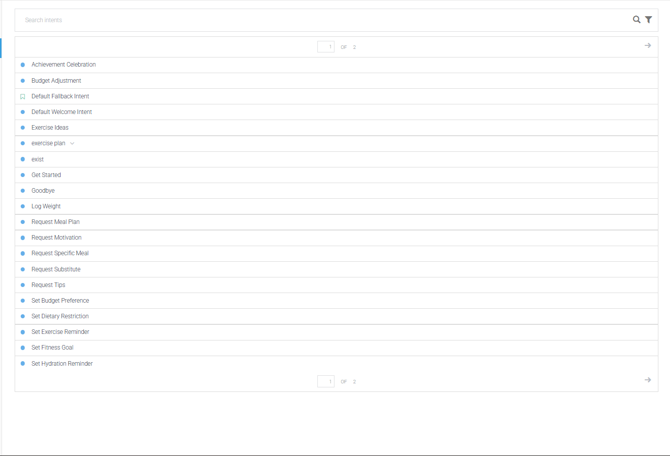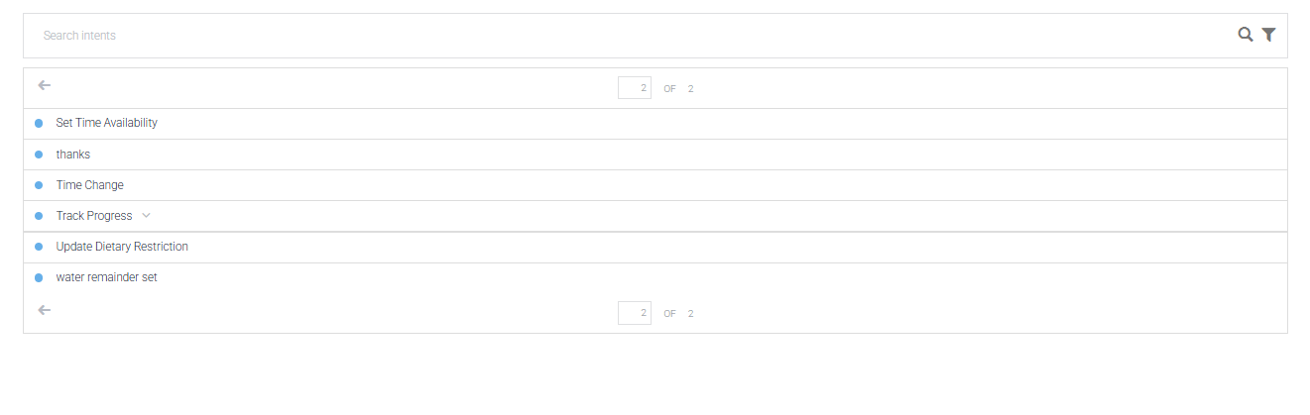The Parameter Nightmare
The biggest technical hurdle was slot-filling. Initially, my SetBudgetPreference intent kept showing [budget_range] literally in responses. After watching three YouTube tutorials and two Dialogflow documentation pages, I realized I hadn't set the parameter value to $budget_range. It took me an entire evening to fix this across all intents.

Rich Responses: Making It Pretty
I used Custom Payload for all major responses because plain text felt boring. The meal plan displays as separate info cards for each meal, which makes it much more scannable

3. Testing & Optimization

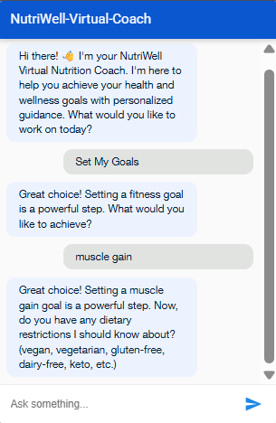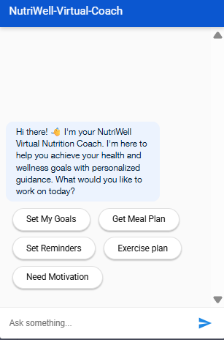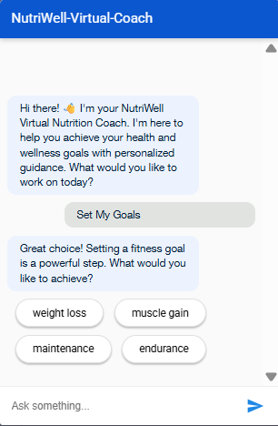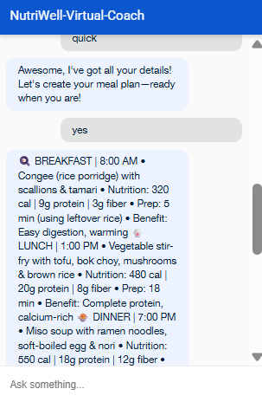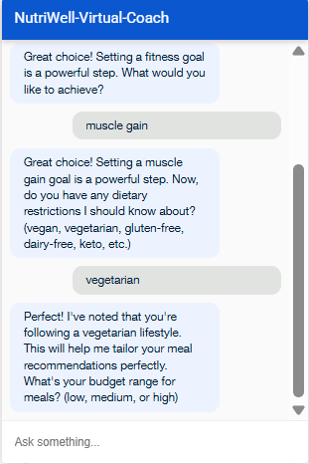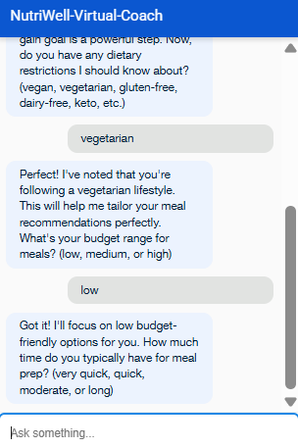5. Challenges & Key Learnings

What Almost Broke Me
The Context Loop: For three days, I was stuck in an infinite loop where the bot would ask for budget, I'd say "low", and it would ask again. Turns out I had awaiting_budget as both input and output context in the same intent, creating a loop. The fix was so simple (change output to awaiting_time) but finding it felt like detective work.
Entity Synonyms Are Underrated: I initially thought 5 synonyms per entity was enough. I was wrong. Real users type "cheapo" and "tight on cash" and "student budget". Building robust synonym lists was tedious but made the bot 10x more user-friendly.

What I Learned
- Start with real conversations: I recorded myself asking a friend for nutrition advice, then modeled the bot's language after that.
- Test early and often: My first "complete" version failed 60% of test cases. Testing after every 3 intents saved me later.
- Documentation is part of development: I wrote my README as I built, not after. Made it way less painful.

6. Ethical AI Considerations
Since this is a health chatbot, I had to be careful:
- No medical advice: I added a disclaimer that this is general wellness guidance, not medical treatment
- Trigger words: If someone mentions "eating disorder" or "starving myself", the bot responds: "I'm a nutrition coach, but this sounds serious. Please consider speaking with a healthcare professional." (No fallback here)
- Data privacy: All user data stays in Dialogflow session context only—no storage

7. Future Enhancements
If I had more time, I'd add:
- Progress tracking dashboard: Visual charts of logged weight/measurements
- Recipe database integration: Real images from Spoonacular API
- Voice support: For hands-free use while cooking
- Community feature: Share achievements with friends

8. Conclusion
Building the NutriWell AI Coach taught me that AI development is 20% coding and 80% understanding humans. The biggest win wasn't getting the technical parts working—it was when my mom said, "This actually feels helpful, not like a robot."
This project gave me practical skills in Dialogflow, but more importantly, it taught me empathy in design. Every intent, entity, and response is a direct result of thinking, "How would I want to be helped?"
Final Stats:
- 25 intents created
- 15 entities with 20+ synonyms each
- 50+ training phrases per major intent
- 5 successful user tests completed
- 1 working chatbot ready for deployment

